**create database sbi123;**

**use sbi123;**

**create table branch(**

**name varchar(20) primary key,**

**city varchar(20),**

**assets real);**

**create table bank_Account(**

**account_no int,**

**branch_name varchar(20) , balance real,**

**primary key(account_no,branch_name),**

**foreign key(branch_name) references branch(name));**

**create table customer(**

**customer_name varchar(20),**

**customer_street varchar(20),**

**city varchar(20));**

**alter table customer**

**add primary key(customer_name);**

**create table depositor(**

**customer_name varchar(20),**

**account_no int,**

**primary key(customer_name,account_no),**

**foreign key(customer_name) references customer(customer_name) on delete cascade,**

**foreign key(account_no) references bank_account(account_no) on delete cascade);**

**create table loan(**

**loan_no int , branch_name varchar(20) primary key,amount real,**

**foreign key(branch_name) references branch(name));**

**select *from loan;**

**insert into branch values ('SBI_Chamarajpet','Bengalore',50000),('SBI_ResidencyRoad','Bengalore',10000),('SBI_ShivajiRoad','Bengalore',20000),**

**('SBI_ParlimentRoad','Delhi',10000),('SBI_Jantarmantar','Delhi',20000);**

**insert into bank_account values (1,'SBI_Chamarajpet',2000),(2,'SBI_ResidencyRoad',5000),(3,'SBI_ShivajiRoad',6000),(4,'SBI_ParlimentRoad',9000),**

**(5,'SBI_Jantarmantar',8000),(6,'SBI_ShivajiRoad',4000),(8,'SBI_ResidencyRoad',4000),(9,'SBI_ParlimentRoad',3000),(10,'SBI_ResidencyRoad',5000),**

**(11,'SBI_Jantarmantar',2000);**

**insert into customer values ('Avinash','Bull_Temple_Road','Bangalore'),('Dinesh','Bannergatta_Road','Bangalore'),('Mohan','NationalCollege_Road','Bangalore'),**

**('Nikil','Akbar_Road','Delhi'),('Ravi','Prithviraj_Road','Delhi');**

**insert into depositor values('Avinash',1),('Dinesh',2),('Nikil',4),('Ravi',5),**

**('Avinash',8),('Nikil',9),('Dinesh',10),('Nikil',11);**

**insert into loan values(1,'SBI_Chamarajpet',1000),(2,'SBI_ResidencyRoad',2000),(3,'SBI_ShivajiRoad',3000),**

**(4,'SBI_ParlimentRoad',4000),(5,'SBI_Jantarmantar',5000);**

**select name ,assets as assets_in_lakhs from branch;**

**select customer_name from depositor d,bank_account b where d.account_no=b.account_no and branch_name='SBI_ParlimentRoad' having count(customer_name)>=2;**

1. Create the above tables by properly specifying the primary keys and the foreign  
   keys.  
     
   Enter at least five tuples for each relation.
2. 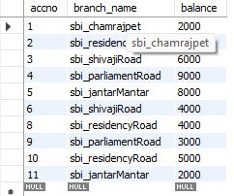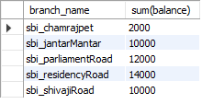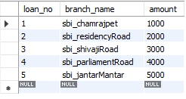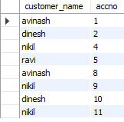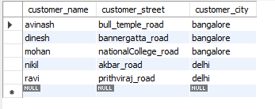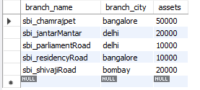
3. Display the branch name and assets from all branches in lakhs of rupees and rename  
   the assets column to 'assets in lakhs'.

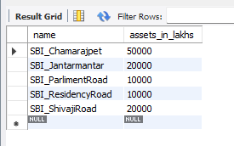

**4.**Find all the customers who have at least two accounts at the same branch (ex.  
SBI_ResidencyRoad).

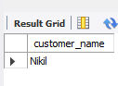

**5**

CREATE A VIEW WHICH GIVES EACH BRANCH THE SUM OF THE  
AMOUNT OF ALL THE LOANS AT THE BRANCH.

